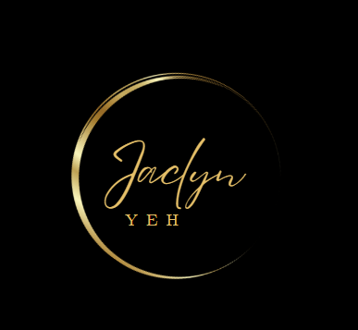

Jacklyn Yeh

100 Nicolls Road

NY 11794

May 3, 2023

Kathy Hochol, Governor of New York State

NYS State Capitol Building

Albany, NY 12224

Subject: Funding for Food Plan

Dear Hochul,

My name is Jaclyn Yeh, a resident of New York City who attended PS 193 (The Gil Hodges School). The school is an urban school situated in a middle-class neighborhood. At the school, we had a School Breakfast and Lunch program that was highly valuable to students. As a student of the school, I knew several learners who were highly dependent on the program to have a full meal, and the situation has continued to the present. During the 2020/2021 school year, more than 1.3 million children benefitted from the state’s free breakfast and lunch program.

However, the current budget instituted by your force has reverted to a system that makes it difficult for children to access meals, particularly those from impoverished families. Students have to sign papers to receive the free breakfast and lunch, and the problem presents a challenge because the requirement disqualifies a significant number of the students, meaning such barriers make it hard for children, particularly those from impoverished families to eat lunch. The lack of lunch threatens the health of these students.

As a legislature, it is essential that you consider the feelings of your constituents concerning your spending plan that could reduce funding for the Breakfast and Lunch program. Students have made their feelings clear as seen in the recent protests where they dumped empty food trays in front of your office. I am requesting that you consider how these protests as a sign of disappointment from the community, and they should motivate you to reconsider the proposed budget to increase funding for the food plan.

I request, as a concerned citizen, that you continue to provide breakfast and lunch for all learners without restrictions, such as the requirement to sign papers. It will play an essential role in securing the health of students, especially those who are highly dependent on the food program. The state has the option of reducing funding for various program, but it should consider the health of the state’s children a priority that makes it impossible to cut the budget for the program. State schools need the free lunch to prevent hunger and positively influence their health. The action will increase the satisfaction of the citizenry and increase their pride in the state government. Accordingly, the state will be a region of health children and proud parents if you increase the funding for school meals in the next budget.

Sincerely yours,

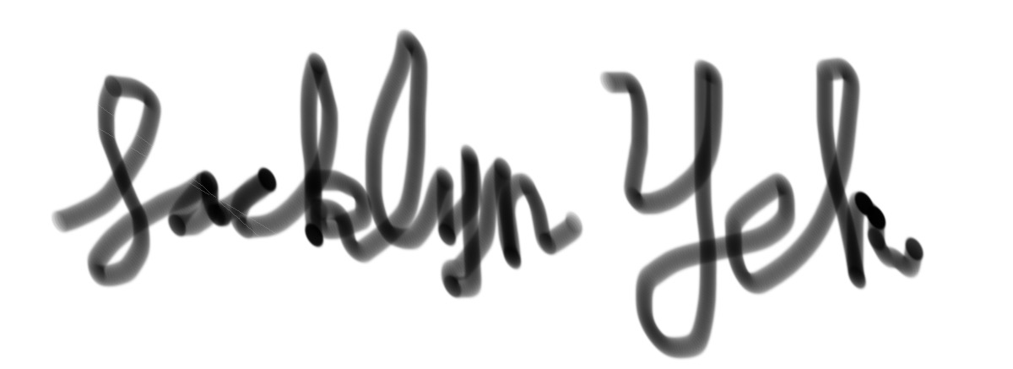

Jacklyn Yeh.